Automating Repetitive Business Processes to Improve Efficiency and Reduce Errors
Sabrina Heng Wei Qi¹, Woo Cheng Shuan²
Faculty of Computing
Universiti Teknologi Malaysia, 8130 Johor Bahru, Johor, Malaysia
¹wei04@graduate.utm.my
²wooshuan@graduate.utm.my

Abstract— This report discusses how automating repetitive business processes can help organizations work faster and make fewer mistakes. Many companies today use tools such as Robotic Process Automation (RPA) to handle daily routine tasks like data entry, billing and report generation. By replacing manual work on important decision-making activities. The paper also looks at real applications of automation in areas such as finance, human resources and supply chain operations. Besides the benefits, some challenges like high setup costs and staff adaption are also discussed. In the end, several suggestions are given on how organizations can start using automation effectively to increase overall efficiency and performance.

Keywords— Automation, Business Process, Efficiency, Error Reduction, Robotic Process Automation, Enterprise Systems, Productivity

- INTRODUCTION

We live in a busy and hectic business environment and any company is constantly seeking means of conducting its daily activities with efficiency and minimizing errors. There are also numerous organizations that waste a significant amount of time on numerous repetitive tasks like data entry, processing invoices and report generations. These are the regular jobs which not only take time and also make the probability of human .

errors high.

An effective method of solving this problem has been automation. Businesses can automate the execution of routine operations by automating the use of technologies such as Robotic Process Automation (RPA) and workflow software with little human intervention. This will enable the workers to concentrate on more productive and creative tasks that will aid in growth of the company.

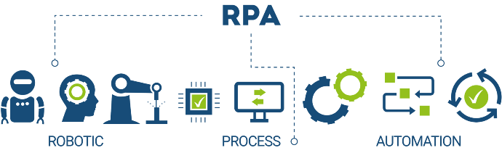
Figure 1.1 Robotic Process Automation (RPA)

Enterprise systems like ERP and CRM are currently focusing on automating the repetitive business processes. It assists organizations in becoming more accurate and more productive, as well as offering better and constant results. The purpose of this paper is to discuss the ability of automation to promote efficiency of businesses as well as decrease error and assist in improved performance in a current business.


Figure 1.2 Enterprise Resource Planning (ERP)

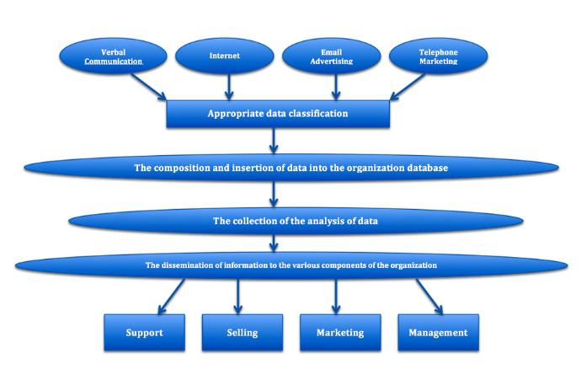
Figure 1.3 Customer Relationship Management (CRM)

- LITERATURE REVIEW

Robotic Process Automation (RPA) employs software bots to streamline repetitive tasks, replicating human interactions within existing systems such as the Enterprise Resource Planning (ERP) platform. [5,6] Its rise in popularity is attributed to its quick and cost-effective implementation, which enhances operational efficiency and reduces expenses. [6,7] This resulted in a strategic transition to Intelligent Automation (IA) or Hyperautomation, which integrates RPA with advanced technologies like AI, Machine Learning (ML), and process mining. This approach is now considered a mandatory strategy, with Gartner predicting significant global adoption of hyperautomation initiatives by 2025. [8,9]

- ANALYSIS

In business, automation is primarily working on repetitive, time-consuming and rule-based tasks. These are typically the type of tasks that are performed by the employees in the same manner daily like data input, form processing or transfer of information between systems. RPA programs such as UiPath [1] and Blue Prism [2] are meant to imitate human interaction with programs. They are able to access systems, transfer files, extract data and make calculations automatically without assistance of a human being.

Automation process typically starts with finding appropriate tasks that can be addressed by a bot and the developers develop or program the bot to execute a series of instructions that are either displayed through the user interface or through APIs by using existing systems. Once deployed, the companies continue to monitor and maintain the automation to make sure that it operates continuously as systems and rules evolve. IBM (2023) states that automation contributes to making business operations more efficient by accelerating the process and minimizing errors in the work of human employees, yet enabling them to continue to do more productive work like planning and making decisions [3].

There is extensive automation in the various departments of enterprises now. In finance, it deals with invoice processing, report making and data reconciliation, hitherto consuming hours of manual work. Onboarding of new employees, updating of records and payroll running are also automated in human resources to support better accuracy. To process service requests, update information and even give prompt answers to common queries, customer service departments have been automated.

Automation is also used in the management of supply chain to track the inventory levels and update on the status of orders and send notifications automatically once the goods have been shipped or received. When performed manually, such tasks are likely to be associated with errors and time wastages. Automation leads to a faster and more regular completion. It is also instrumental in compliance and reporting in which accuracy and updates are essential. In general, the repetitive business process automation helps organizations to save time, reduce costs and minimize the possibility of human error and ensure increased consistency in business operations [4].

- ADVANTAGES

RPA offers compelling operational benefits, especially for repetitive, high-volume tasks.[6] Robots carry out jobs with precision, maintaining attention and achieving exceptional accuracy. Automated systems report up to 99.8% accuracy in data entry and reduce human errors by 80% to 95%, a level of precision vital for reducing compliance risk and financial liability. [10] Beyond accuracy, RPA increases productivity. Bots work around the clock accelerating operations by 30% to 70% and enabling businesses to quickly scale to meet changing demands. Automating tedious work frees human employees to focus on strategic tasks requiring critical thinking, which increases morale and provides a positive Return on Investment (ROI). [6,10]

- DISADVANTAGES

According to Ernst & Young, up to 50% of RPA initiatives fail, despite the fact that many RPA programs struggle. [7] These failures stem primarily from technical design flaws and poor governance. A major cause is Technical Brittleness and Debt: traditional RPA interacts with systems at the User Interface (UI) level, rather than robust APIs, making the automated scripts brittle and prone to breaking after any small application update, which leads to high maintenance costs and technical debt. [7] The low-code nature of RPA often encourages unauthorized "shadow deployments" by untrained users, increasing complexity and cybersecurity risks. [11] Finally, Security and Compliance Risks are critical, as bots handle sensitive credentials and data. Without a strong governance framework (e.g., a Center of Excellence), organizations face risks from unauthorized access, credential theft, and regulatory non-compliance. [11]

- RECOMMENDATIONS

The organization should consider starting with small and simple processes that are easy to automate to make automation successful. It is possible to begin with monotonous and systematic tasks, which can decrease the risks and enable teams to achieve visible outcomes before moving to more significant projects. Employees should as well as involved early in the automation plan in order to get familiar with how the system would work and have confidence in the use of the system. Resistance may be mitigated through proper training and communication and the workers are made to concentrate on higher-value activities.

Companies should also verify their automated systems to make sure they are always correct and work well, especially when business regulations or software keep changing. The optimal approach to the balance between speed and quality is to combine automation and human control. Last but not least, the organizations must consider the cost and benefits of automation so that it can be seen as supporting long-term objectives and improving the overall performance of the business.

- CONCLUSION

In conclusion, automating repetitive business processes has become a key strategy for organizations aiming to enhance efficiency, accuracy, and overall performance. By using technologies such as Robotic Process Automation (RPA), companies can reduce human errors, shorten processing times, and allow employees to focus on higher-value and strategic tasks. The integration of automation within enterprise systems like ERP and CRM has shown significant improvements in productivity and operational consistency across various departments including finance, human resources, and supply chain management.
However, successful automation requires careful planning, proper governance, and continuous monitoring to address challenges such as high setup costs, technical maintenance, and employee adaptation. When implemented effectively, automation not only streamlines operations but also drives innovation, scalability, and competitiveness in the modern business environment. Ultimately, the strategic adoption of automation serves as a powerful tool for organizations to achieve sustainable growth and digital transformation.

- ACKNOWLEDGEMENT

We would like to sincerely thank Universiti Teknologi Malaysia's Faculty of Computing for providing the tools and assistance that made this analysis possible. We would especially like to thank our mentors and colleagues, whose advice and ideas were very helpful during this project.

- REFERENCES

[1] UiPath Inc. (2025). What Is Robotic Process Automation? Uipath.com. https://www.uipath.com/rpa/robotic-process-automation
[2] How does RPA Work? (n.d.). SS&c Blue Prism. https://www.blueprism.com/guides/robotic-process-automation-rpa/how-does-rpa-work/
[3] IBM. (2021, September 22). What is robotic process automation (RPA)? Ibm.com. https://www.ibm.com/think/topics/rpa
[4] Casey, K. (2020, July 30). How to explain Robotic Process Automation (RPA) in plain English. Enterprisersproject.com. https://enterprisersproject.com/article/2019/5/rpa-robotic-process-automation-how-explain
[5] Fantina, M., & Fernandez, A. (2021). Robotic Process Automation (RPA): A systematic review. ResearchGate. https://www.researchgate.net/
[6] ResearchGate. (2024). Examining the effects of robotic process automation on operational efficiency and business process optimization: Literature study. https://www.researchgate.net/
[7] Smartflow. (n.d.). How RPA reduces human error. https://www.smartflow.com/
[8] Naviant. (n.d.). Why RPA projects fail. https://www.naviant.com/
[9] Advsyscon. (n.d.). Why RPA fails: Top causes of failure and technical debt. https://www.advsyscon.com/
[10] Aqusag Technologies. (2024). The future of robotic process automation (RPA) in 2025: Trends and innovations. https://www.aqusag.com/
[11] Auxiliobits. (2025). RPA in 2025: Trends, tools, and what CIOs should prepare for. https://www.auxiliobits.com/

